Placement Dataset Analysis

Placement Dataset:

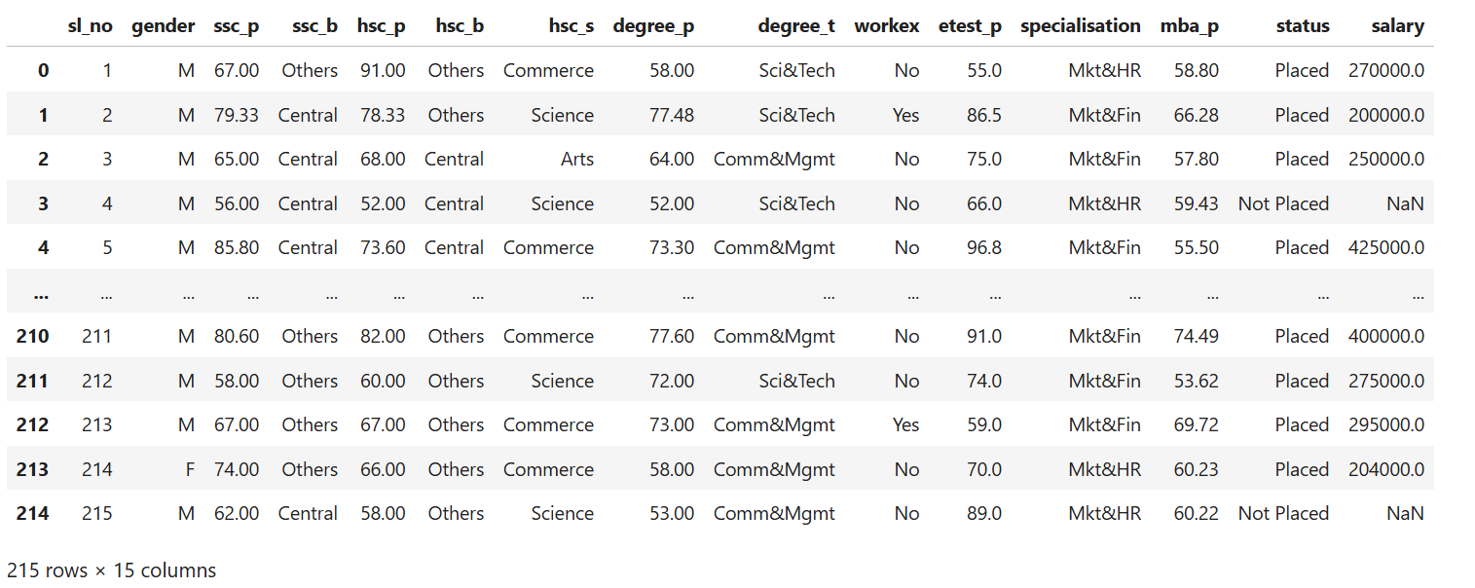

1)Replace the NaN values with correct value. And justify why you have chosen the same.

Among 15 columns only salary has 67 NaN values. Salary contains NaN values only for those who have not placed. Replace those NaN values by 0 because 0 means nothing, they are not receiving any salary.

2)How many of them are not placed?

67 students are not placed.

3)Find the reason for non-placement from the dataset?

Placed students academic mean: 70.12952702702702
Non-Placed students academic mean: 59.024577114427856

The reason for non-placement from the dataset is academic mean.

4)What kind of relation between salary and mba_p

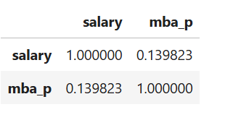

There is a low degree positive correlation between salary and mba_p

5)Which specialization is getting minimum salary?

Specialisation Salary
Mkt&Fin 298852.631579
Mkt&HR 270377.358491

Marketting and Human Resource is getting minimum salary.

6)How many of them getting above 500000 salaries?

Number of Students getting above 500000 salaries are 3.

7)Test the Analysis of Variance between etest_p and mba_p at signifance level 5%.(Make decision using Hypothesis Testing)

Null hypothesis - There is no significant difference between etest_p and mba_p
Alternate hypothesis - There is significant difference between etest_p and mba_p
pvalue<0.05, so reject null hypothesis and accept alternate hypothesis

8)Test the similarity between the degree_t(Sci&Tech) and specialisation(Mkt&HR) with respect to salary at significance level of 5%.(Make decision using Hypothesis Testing)

Null hypothesis - There is no similarity between the degree_t(Sci&Tech) and specialisation(Mkt&HR) with respect to salary
Alternate hypothesis - There is similarity between the degree_t(Sci&Tech) and specialisation(Mkt&HR) with respect to salary
pvalue<0.05, so reject null hypothesis and accept alternate hypothesis

9)Convert the normal distribution to standard normal distribution for salary column

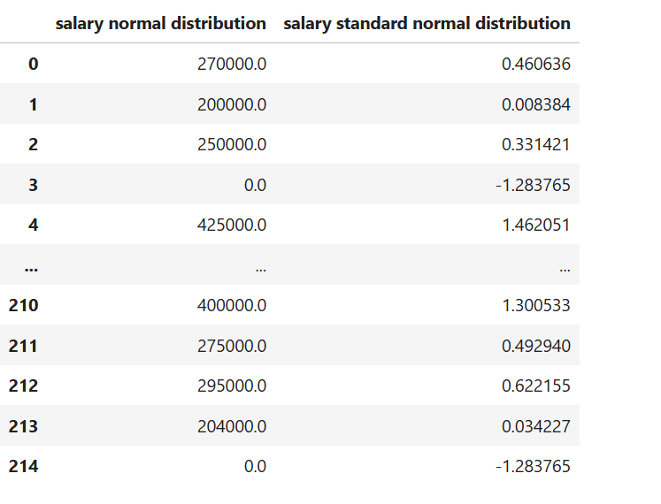

10)What is the probability Density Function of the salary range from 700000 to 900000?

The area of between range[700000,900000]:0.0005973310593974868

11)Test the similarity between the degree_t(Sci&Tech)with respect to etest_p and mba_p at significance level of 5%.(Make decision using Hy- pothesis Testing)

Null hypothesis - There is no similarity between the degree_t(Sci&Tech) with respect to etest_p and mba_p

Alternate hypothesis - There is similarity between the degree_t(Sci&Tech) with respect to etest_p and mba_p

pvalue<0.05, so reject null hypothesis and accept alternate hypothesis

12)Which parameter is highly correlated with salary?

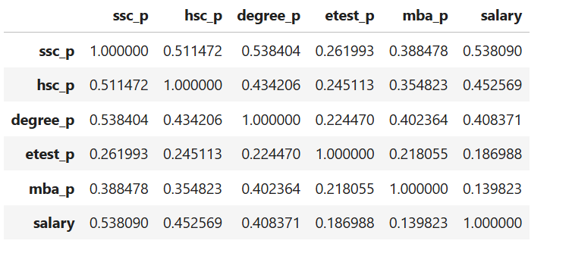

So, ssc_p parameter is highly correlated with salary.

13) plot any useful graph and explain it.

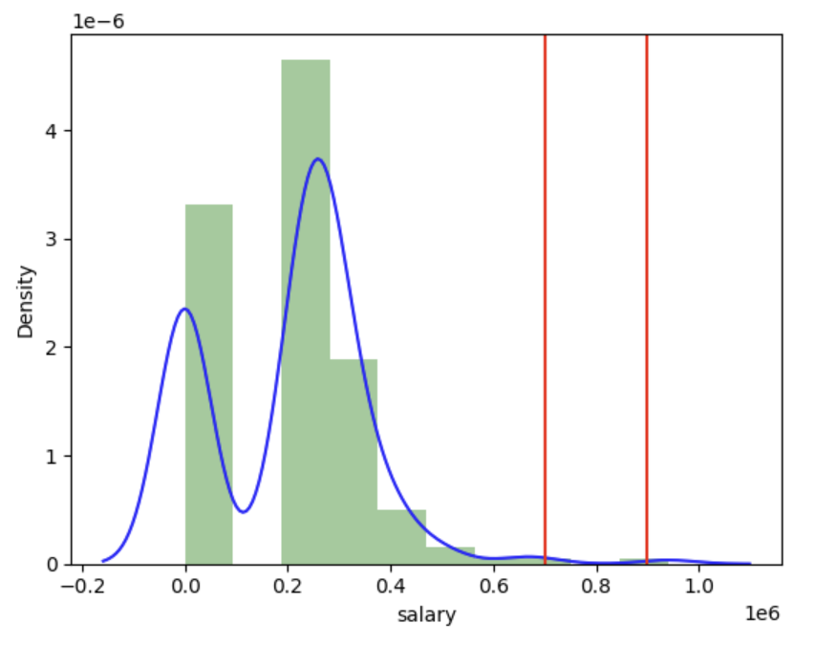
The probability Density Function of the salary range from 700000 to 900000. The area of between range[700000,900000]:0.0005973310593974868.

